Week2 Assignment
Kalpana Renjarla
CT5150 Data Science Tools – CRN196
Perkins
New England College
07-23-2026

Assignment Overview
This document answers Exercises 3, 4, and 6 from Section 1.2.5. The companion R Markdown file contains the executable code and produces the requested graphs when knitted to HTML.
Exercise 3
Question. Create a scatterplot of bill_depth_mm versus bill_length_mm and describe the relationship.
# Plot two numerical bill measurements and color by species.
ggplot(penguins, aes(
x = bill_length_mm,
y = bill_depth_mm,
color = species
)) +
geom_point(na.rm = TRUE) +
labs(
title = "Penguin Bill Depth versus Bill Length",
x = "Bill length (mm)",
y = "Bill depth (mm)",
color = "Species"
) +
theme_minimal()
Interpretation. The points form clusters associated with the three penguin species, so the combined relationship is not described well by one simple straight line. Gentoo penguins generally have longer but shallower bills, Chinstrap penguins tend to have longer and deeper bills, and Adelie penguins usually have shorter bills. Within the species clusters, bill depth and bill length tend to have a positive relationship. Species is therefore important for understanding the pattern.
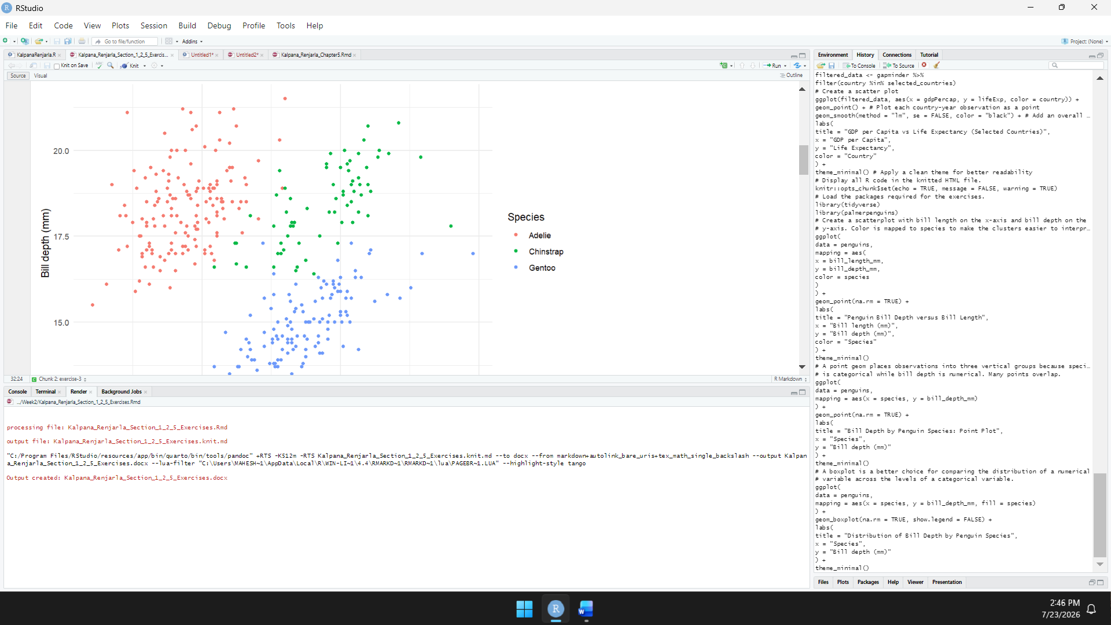
Exercise 4
Question. Explain what happens in a scatterplot of species versus bill_depth_mm and identify a better geom.
# A point plot produces three vertical groups with overlapping points.
ggplot(penguins, aes(x = species, y = bill_depth_mm)) +
geom_point(na.rm = TRUE) +
labs(x = "Species", y = "Bill depth (mm)") +
theme_minimal()
# A boxplot better compares a numerical distribution across categories.
ggplot(penguins, aes(
x = species,
y = bill_depth_mm,
fill = species
)) +
geom_boxplot(na.rm = TRUE, show.legend = FALSE) +
labs(x = "Species", y = "Bill depth (mm)") +
theme_minimal()
Interpretation. The point plot creates three vertical groups because species is categorical. Many points overlap, so the distributions are difficult to compare. A boxplot is a better geom because it summarizes the median, spread, and possible outliers for each species. It shows that Gentoo penguins generally have shallower bills, while Chinstrap penguins have the highest typical bill depth.
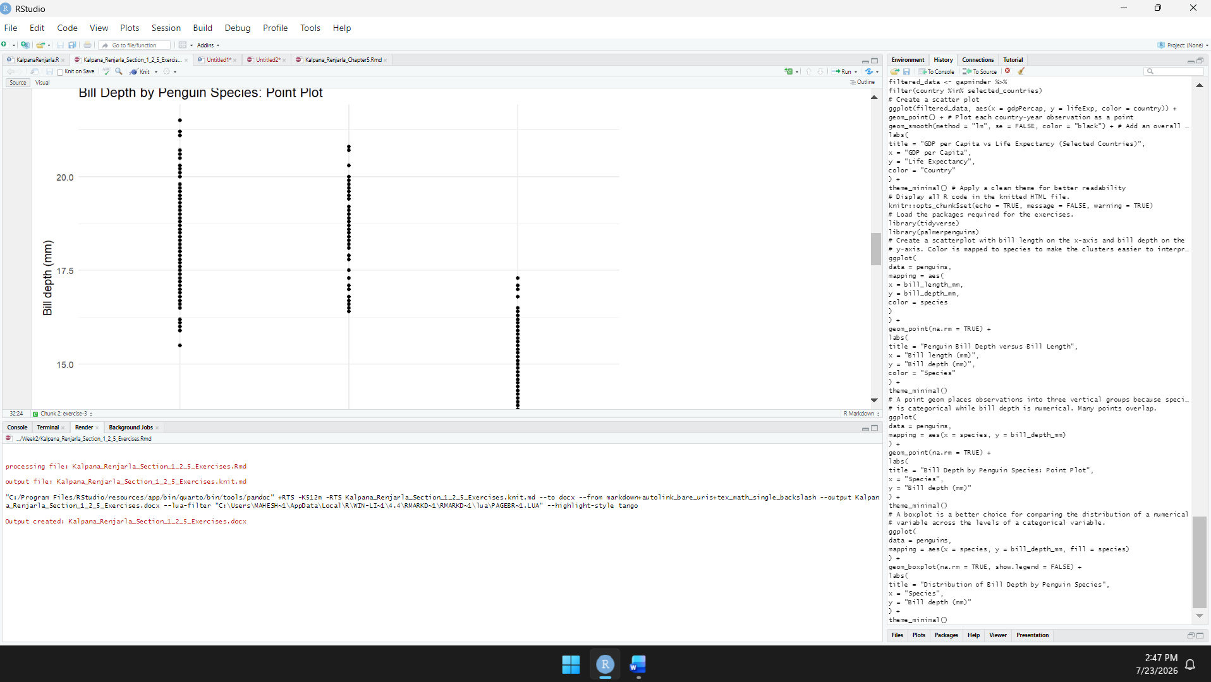
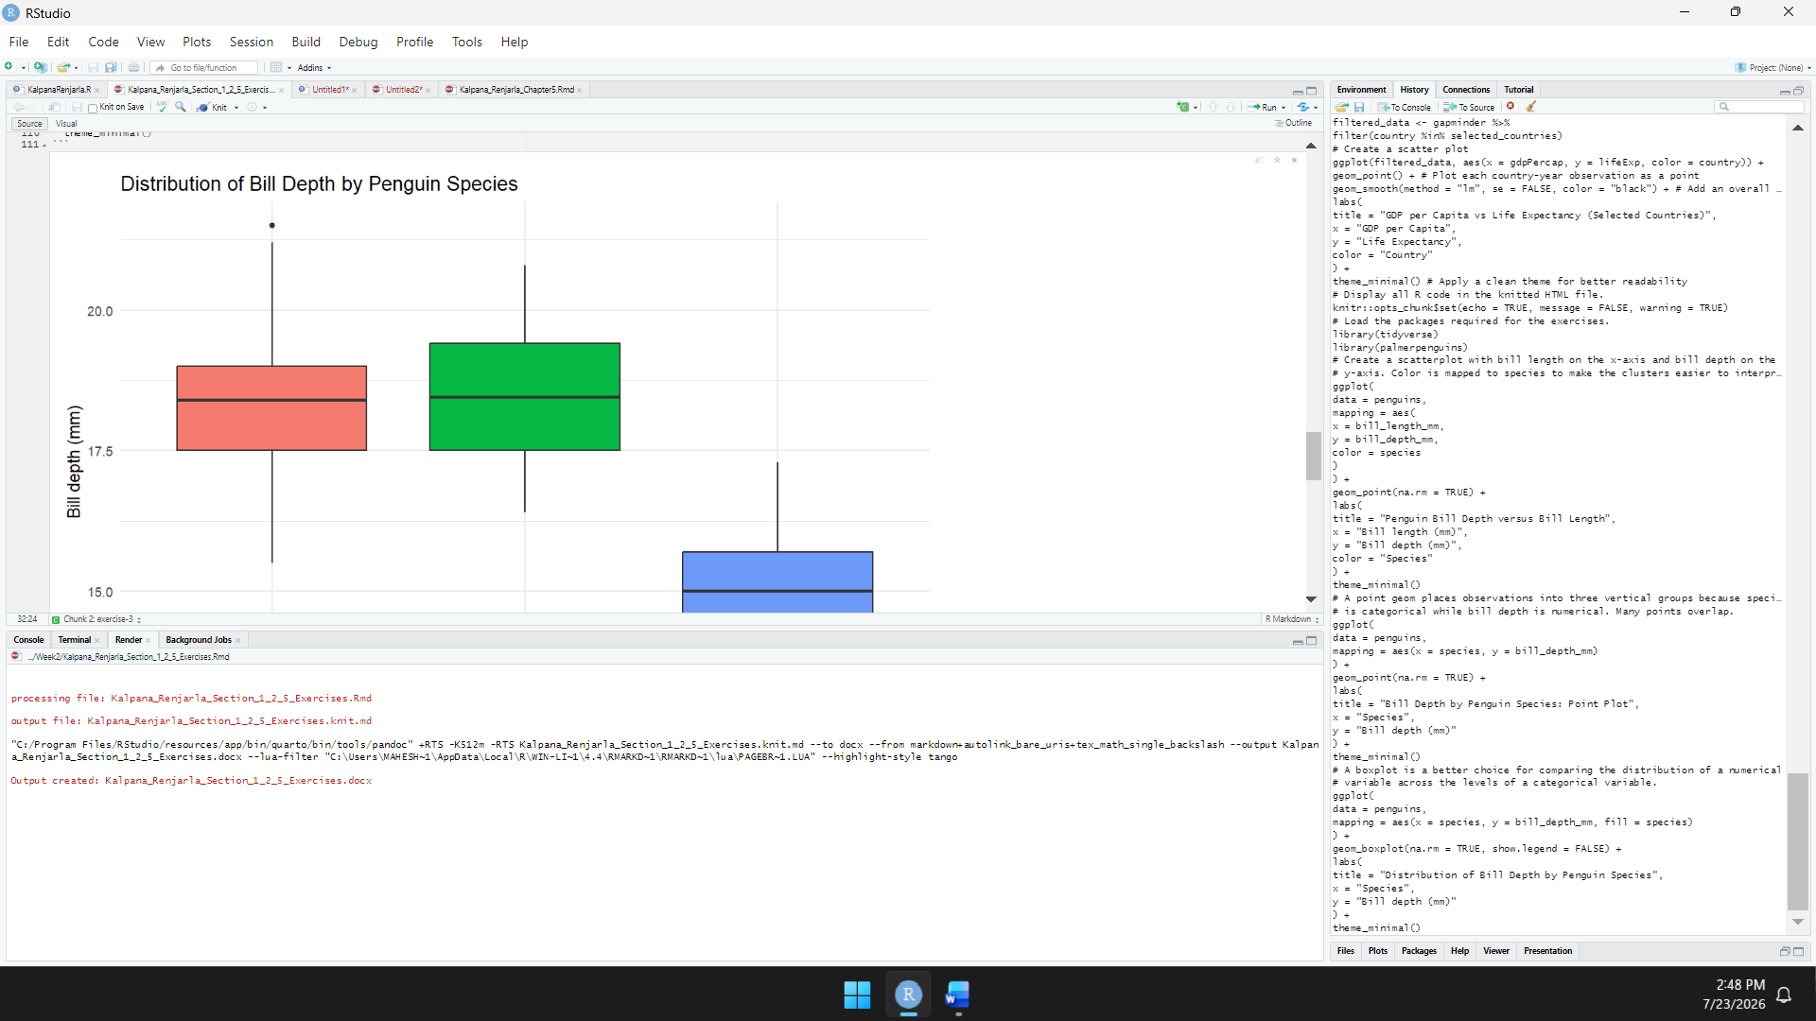
Exercise 6
Question. Explain na.rm in geom_point(), identify its default, and create a scatterplot using na.rm = TRUE.
Answer. The na.rm argument controls how missing values are handled. Its default value is FALSE. With the default, incomplete rows are removed and ggplot2 prints a warning. When na.rm = TRUE, incomplete rows are removed silently. It does not estimate or replace the missing measurements.
# Remove incomplete observations silently and draw the scatterplot.
ggplot(
penguins,
aes(x = bill_length_mm, y = bill_depth_mm)
) +
geom_point(
na.rm = TRUE,
color = "#2C7FB8",
alpha = 0.75
) +
labs(
title = "Bill Measurements with Missing Values Removed",
subtitle = "geom_point(na.rm = TRUE)",
x = "Bill length (mm)",
y = "Bill depth (mm)"
) +
theme_minimal()
Interpretation. The scatterplot contains observations with both bill-length and bill-depth values. Rows missing either value are omitted without a warning because na.rm is TRUE.
